**Gallery of Screen Captures: Super Bug Zapper**

**Sierra Williams, 22466205**

1. When the game is opened this is the screen you will see. The black square is the game board. The white circle is the playing area.

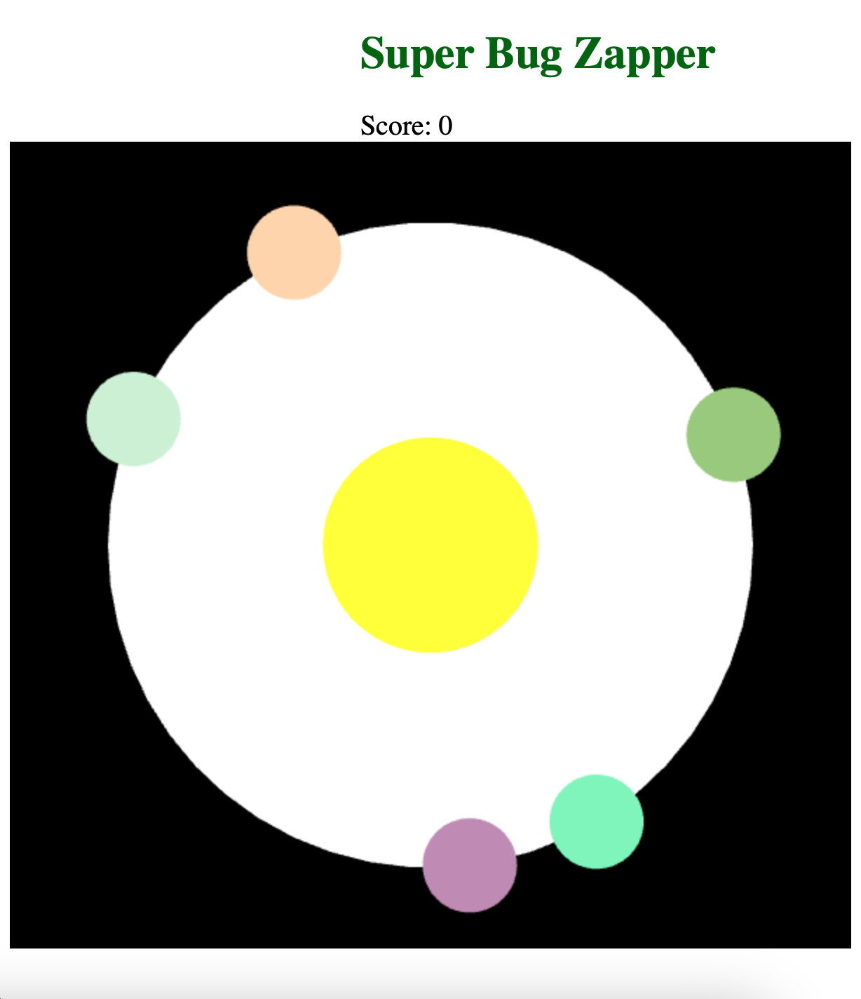

1. This screen is just before two bacteria merge.

1. This screen is what it looks like when two bacteria merge together, the bigger one stays and gets larger, the smaller one is deleted.

1. This screen is what shows when you win. You successfully eradicated 10 bacteria!

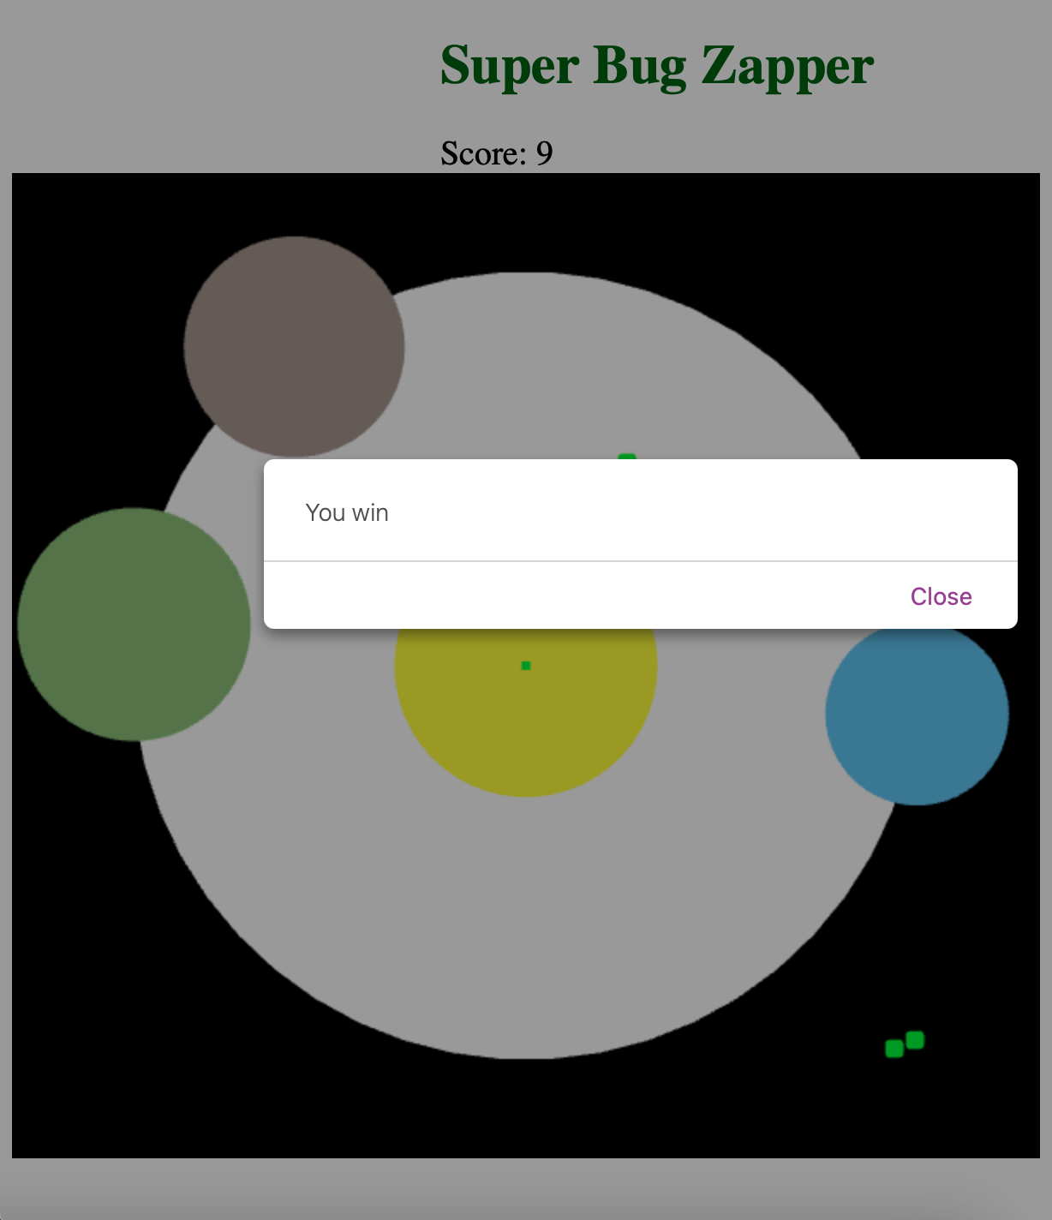

1. The next screen is what shows when 2 of the bacteria touch the middle yellow circle. You lost.

